1. Items Table in SQL Server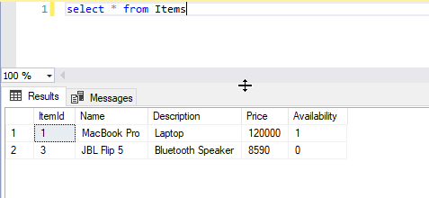
2. Add New Item

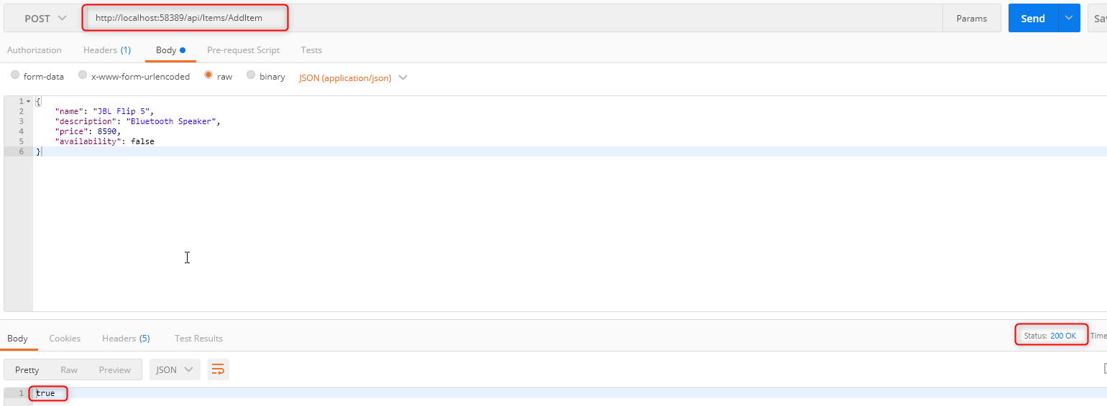

1. Get Method Result in Postman

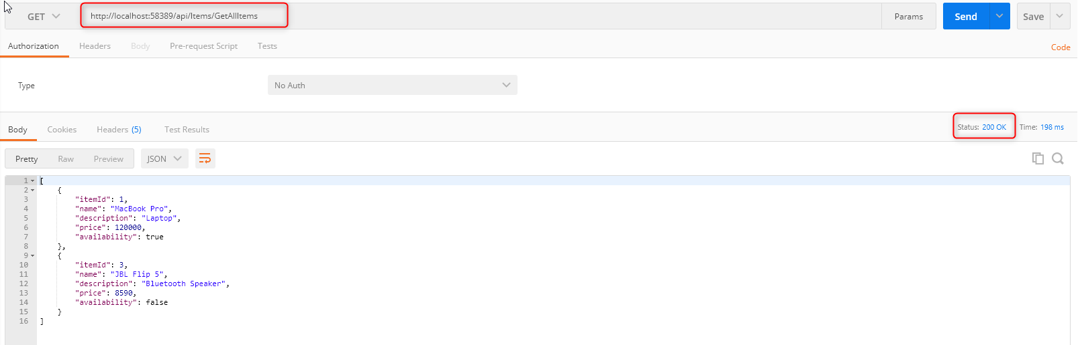

1. Update method result (Positive case)

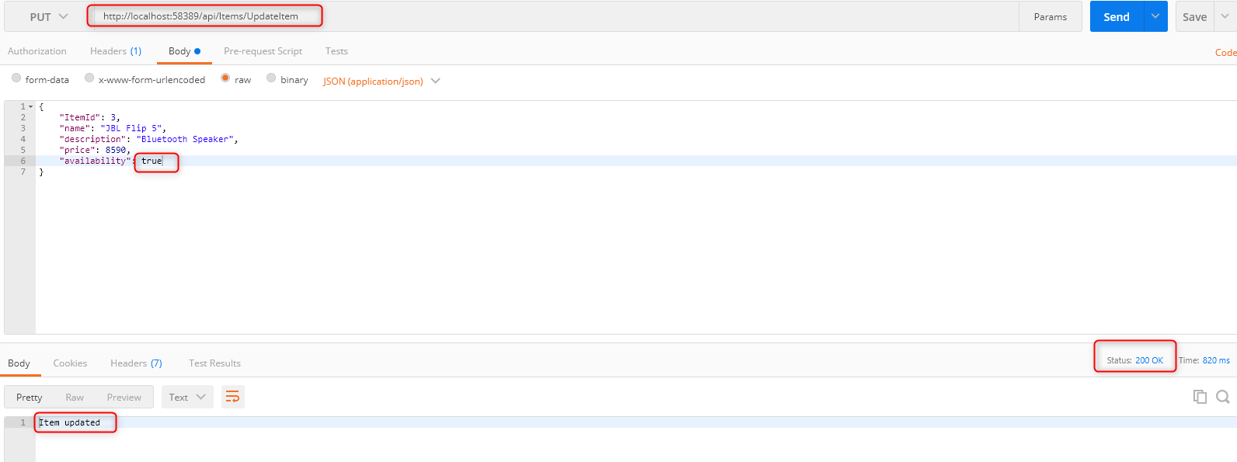

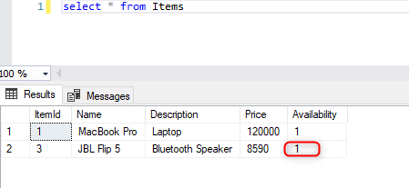

1. Update method result (Negative case)

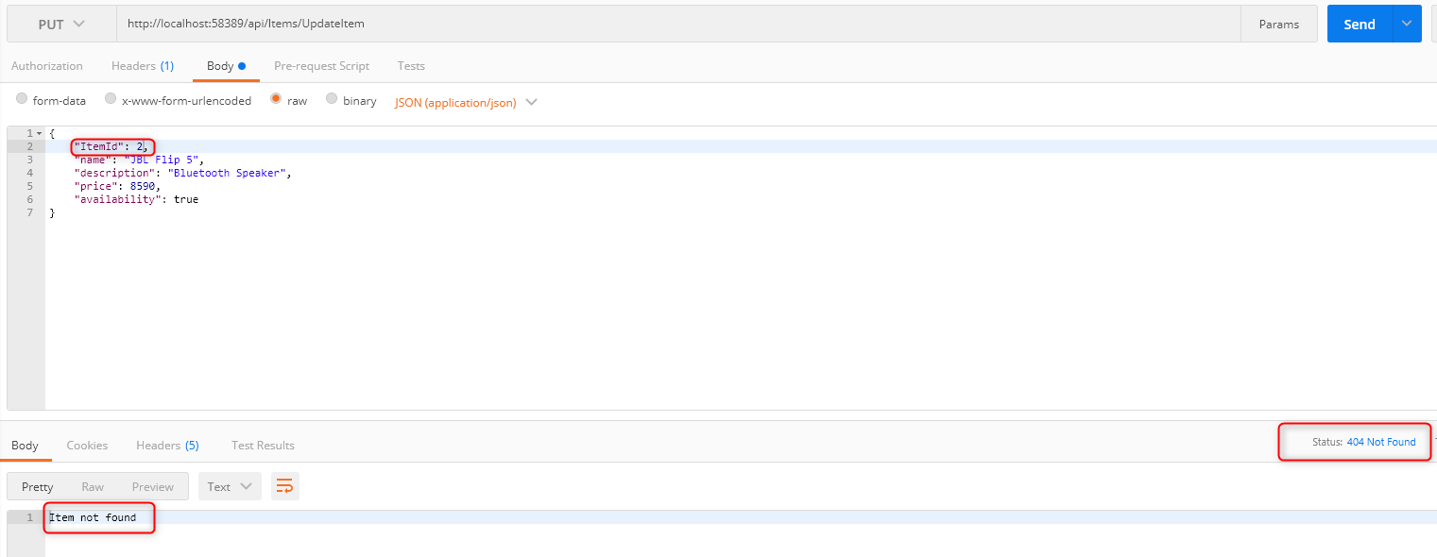

1. Delete Item (Negative Case)

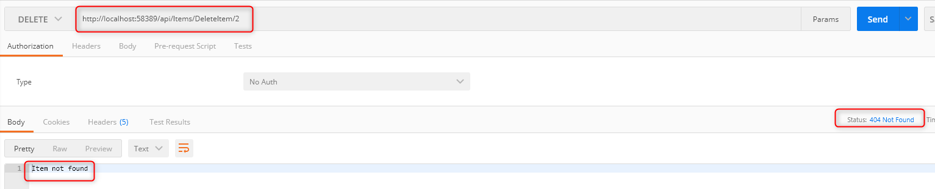

1. Delete Item (Positive Response)

